VIRTUAL WHITE BOARD

SOFTWARE REQUIREMENTS SPECIFICATION

Prepared for: Virtual White Board Web Application

This Software Requirements Specification (SRS) document describes the functional and non-functional requirements of a Virtual White Board system. The application is designed to provide a digital workspace where users can write, draw, organize ideas and collaborate with other users in real time through the internet.

1.INTRODUCTION

Purpose

The purpose of this document is to define the complete requirements for the Virtual White Board system. It describes what the system should do, the services it should provide, the users who will use it and the limitations under which it operates. This document acts as a reference for developers, testers, project managers and users during the development and maintenance of the application.

Scope

The Virtual White Board is a web-based application that provides a shared digital canvas. Users can create a board, draw freehand sketches, write text, insert shapes, select colors, erase unwanted content and save their work. Multiple authorized users can access the same board and collaborate in real time. The system is intended for online teaching, brainstorming, team discussions, presentations and planning activities.

Create, open, update and delete whiteboards.

Draw using pen, eraser, shapes and text tools.

Select different colors and stroke sizes.

Collaborate with multiple users in real time.

Save, export and share whiteboard content.

Access the application through modern web browsers.

Definitions, Acronyms and Abbreviations

W/B – White Board

SRS – Software Requirements Specification

UI – User Interface

DB – Database

CRUD – Create, Read, Update and Delete

WebSocket – A communication technology used for real-time updates

References

IEEE Software Requirements Specification guidelines.

UML 2.5 Specification.

Standard web technologies such as HTML, CSS and JavaScript.

2.OVERALL DESCRIPTION

Product Perspective

The Virtual White Board is a standalone web application that can be accessed through a web browser without installing a separate desktop application. The system consists of a user interface, application server, real-time communication service and database. The user interface provides the digital canvas and drawing tools. The server manages authentication, boards, sharing and storage. Real-time communication allows changes made by one user to appear on the screens of other connected users.

Product Functions

User registration and login.

Secure user authentication and session management.

Creation of new whiteboards.

Viewing, editing and deleting existing whiteboards.

Freehand drawing using a pen or pencil tool.

Adding text, lines, rectangles, circles and other basic shapes.

Changing colors and stroke thickness.

Erasing individual drawings or clearing the board.

Real-time synchronization of changes between users.

Saving board content in the database.

Exporting the board for later use or presentation.

Sharing a board with other users.

3.User Characteristics

The system is designed for students, teachers, professionals, project teams and general users who require an online collaborative workspace. Basic knowledge of using a web browser and common drawing tools is sufficient. The interface should be simple so that first-time users can quickly understand the available options.

Operating Environment

The application shall operate on modern desktop and mobile browsers. Supported environments include Chrome, Firefox, Microsoft Edge and Safari. The system should work on Windows, Linux, macOS, Android and iOS devices with a stable internet connection.

Design and Implementation Constraints

A stable internet connection is required for live collaboration.

Real-time communication depends on WebSocket or an equivalent technology.

The application must be compatible with supported modern browsers.

User data and shared boards must be stored securely.

The interface should remain responsive on different screen sizes.

Assumptions and Dependencies

It is assumed that users have a compatible browser and internet connection. The system depends on the availability of the web server, database and real-time communication service. If the network connection is interrupted, real-time updates may be delayed until connectivity is restored.

4.SPECIFIC REQUIREMENTS

Functional Requirements

FR1: User Registration

The system shall allow a new user to create an account by providing the required registration information.

FR2: User Login

The system shall allow registered users to log in securely and access their personal whiteboards.

FR3: Board Creation

The user shall be able to create a new whiteboard and assign a suitable name to it.

FR4: Board Management

The user shall be able to open, rename, update and delete whiteboards created by the user.

FR5: Drawing Tools

The user shall be able to draw on the digital canvas using a pen or freehand drawing tool.

FR6: Eraser Tool

The user shall be able to remove unwanted drawings or clear selected content.

FR7: Shapes and Text

The user shall be able to add basic shapes and text to the whiteboard.

FR8: Color and Size Selection

The user shall be able to choose drawing colors and adjust the thickness of drawing strokes.

FR9: Real-Time Collaboration

Multiple users shall be able to work on the same shared whiteboard, and updates shall be synchronized with minimum delay.

FR10: Save and Export

The system shall allow users to save board content and export the completed whiteboard.

FR11: Sharing

The user shall be able to share a whiteboard with authorized users.

FR12: Logout

The system shall allow users to log out securely and terminate their active session.

3.2 Use Cases

Register a new user account.

Log in to the application.

Create or open a whiteboard.

Draw and edit content.

Invite or share with collaborators.

Save or export the completed board.

Log out from the application.

5. Non-Functional Requirements

Performance

The application should provide a smooth drawing experience and should synchronize normal user actions with minimum visible delay. Common operations such as opening a board, selecting a tool and drawing should respond quickly under normal network conditions.

Usability

The system should provide a simple, clear and user-friendly interface. Frequently used tools such as pen, eraser, shapes, text, colors and save options should be easy to locate. The application should require minimal training.

Reliability

The system should save valid user changes reliably and should recover gracefully from temporary connection problems. The application should avoid loss of saved whiteboard data and should provide appropriate error messages when an operation fails.

Security

User accounts and whiteboard data should be protected from unauthorized access. Authentication data should be handled securely, and users should only be able to access boards for which they have the required permission.

Availability

The system should be available whenever the server and supporting services are operational. Planned maintenance should be performed in a controlled manner to minimize disruption to users.

Scalability

The design should support an increasing number of users and boards. The real-time collaboration component should be capable of handling multiple active users without significantly reducing the quality of the user experience.

Maintainability

The software should be developed using modular components so that new tools and features can be added with minimal impact on existing functions. Clear documentation and readable code should support future maintenance.

Compatibility

The application should support commonly used modern browsers and should adapt its user interface to desktop, tablet and mobile screens where practical.

6.External Interface Requirements

User Interface

The main interface shall contain a drawing canvas, toolbar, color controls, shape and text options, board management controls and sharing options. The layout should clearly show the active tool and provide feedback after important actions such as saving or sharing.

Software Interface

The application may communicate with a database for user and board storage and with a real-time service for collaboration. APIs should exchange data using well-defined request and response formats.

Communication Interface

The system shall use standard internet communication protocols. Real-time updates may use WebSocket technology or another equivalent bidirectional communication mechanism.

SYSTEM CONSTRAINTS

Real-time collaboration requires a stable internet connection.

Supported browser versions may change as web standards evolve.

The quality of collaboration depends partly on network speed and latency.

The system must operate within the storage and processing limits of the selected hosting environment.

Only authorized users should be allowed to access private shared boards.

ASSUMPTIONS AND DEPENDENCIES

Users have access to a supported web browser.

Users have a stable internet connection for online collaboration.

The database service is available for storing user and board information.

The real-time communication service is operational when collaboration is required.

Users are responsible for keeping their login credentials secure.

ACCEPTANCE CRITERIA

The Virtual White Board system will be considered acceptable when a registered user can successfully log in, create a whiteboard, use drawing and editing tools, save the board, share it with another user and observe synchronized updates during real-time collaboration. The application should also provide reliable operation, a user-friendly interface and reasonable security for user accounts and stored data.

7.FUTURE ENHANCEMENTS

Audio and video communication between collaborators.

Cloud backup and version history for whiteboards.

Additional drawing tools and templates.

Importing images and documents into the board.

Role-based permissions for owners, editors and viewers.

AI-assisted diagram and shape recognition.

Offline editing with later synchronization.

Advanced export formats and presentation mASSUMPT8.lCONCLUSION

The Virtual White Board system provides an effective digital platform for writing, drawing and collaborative work. By combining easy-to-use drawing tools with real-time synchronization and secure board management, the system can support educational and professional activities. This SRS document defines the major requirements and constraints needed to guide the design, development, testing and future enhancement of the application.

UML DIAGRAM
1.USE CASE DIAGRAM
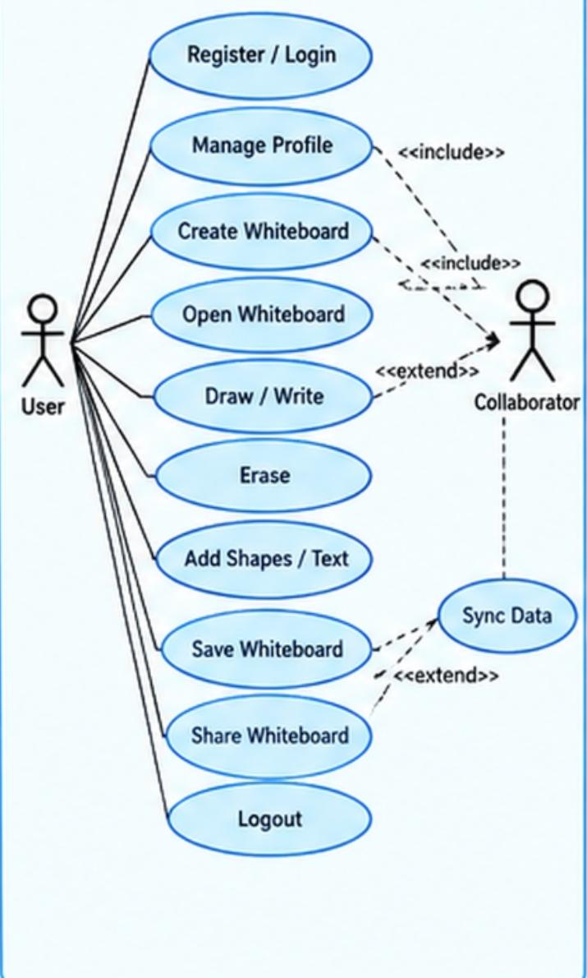
2.CLASS DIAGRAM
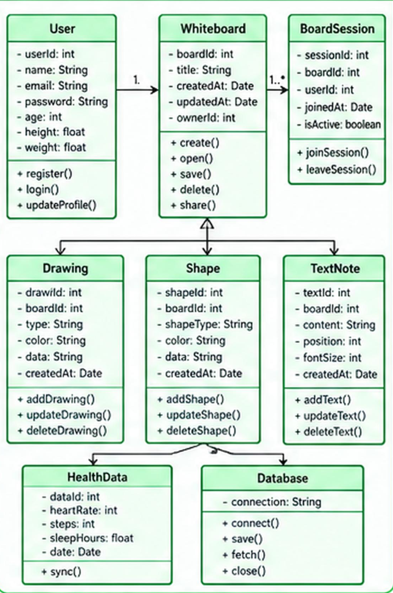

3.SEQUENCE DIAGRAM
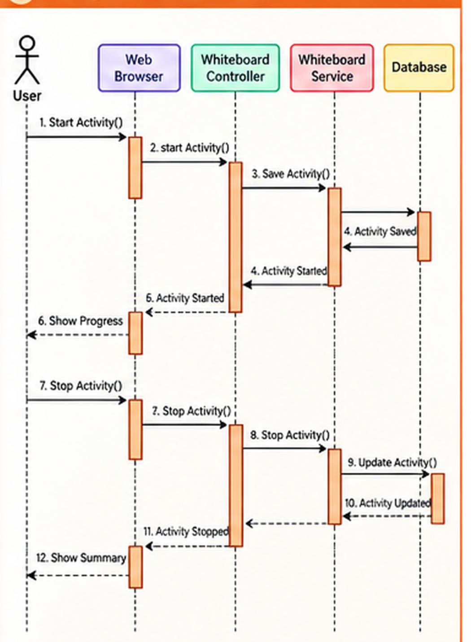

4.COLLABORATION DIAGRAM
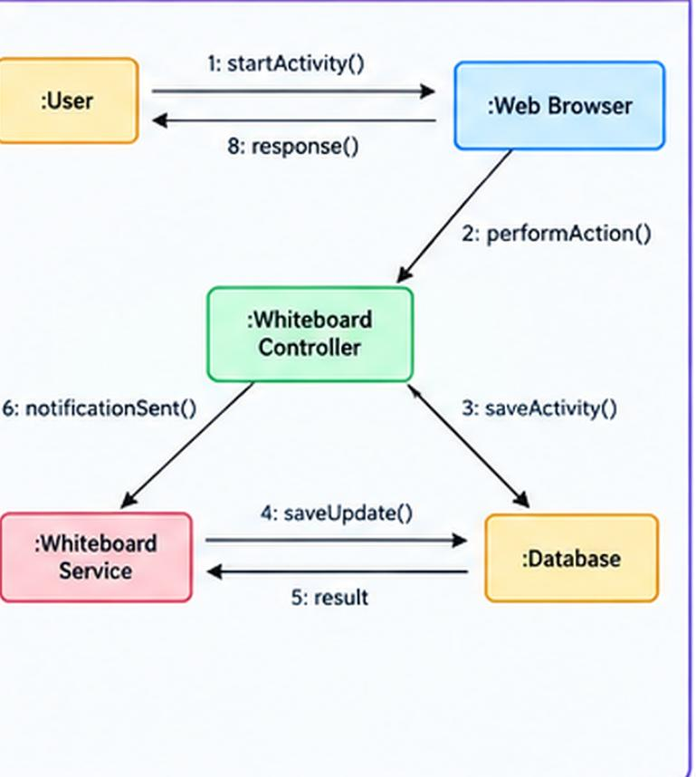

5.ACTIVITY DIAGRAM
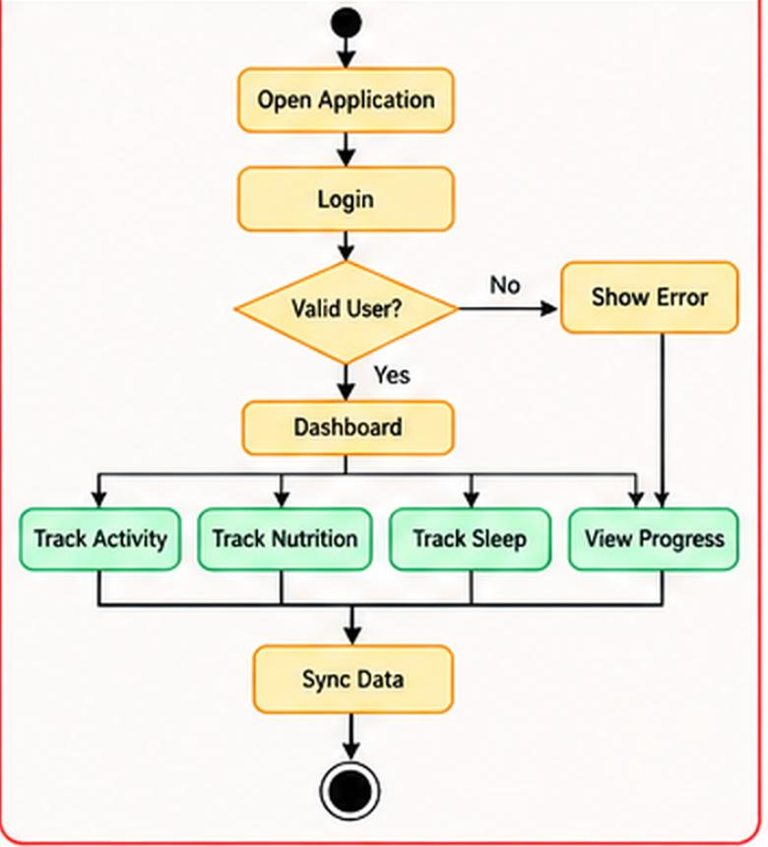

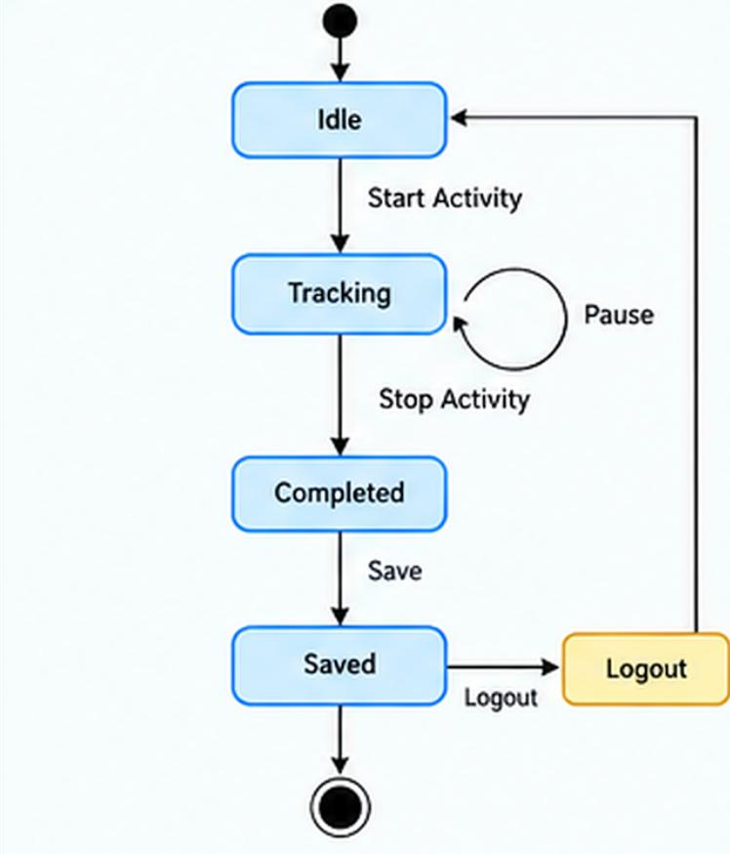
6.STATE CHART DIAGRAM
